**Rock Paper Scissors Task:**

* I designed a responsive UI for the rock-paper-scissors game using JavaScript. To begin, I created an index.html file that contains the pictures that will be displayed on the webpage, as well as a link to a style sheet and a JavaScript file.
* The style.css file is used to style the homepage, such as aligning the rock, paper, and scissors pictures.
* I utilized the random number generator function in the JavaScript file and categorized the results depending on the numbers generated. The Math.random() method is used to generate a random number between 0 and 2 and choose rock, paper, or scissors for the computer at random.
* This game has five chances to decide the winner, whoever gets the highest points.
* the function compareInputs() is used to compare inputs given by the player and the computer and it checks whether they both are same or else compares who won the match.

**Output:**

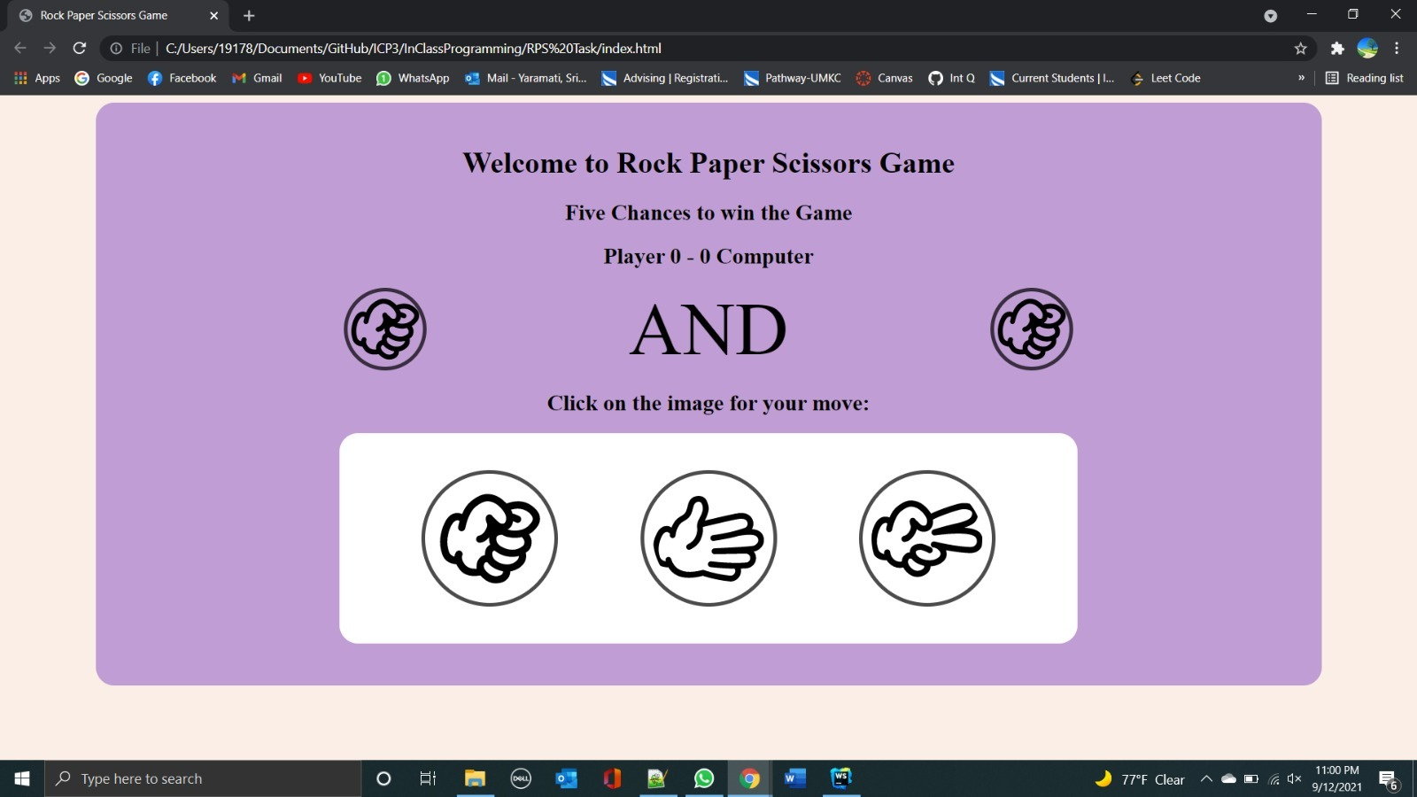

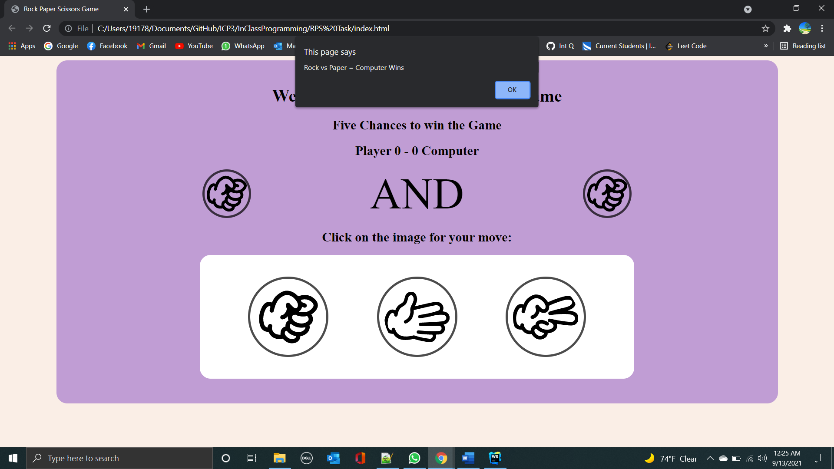

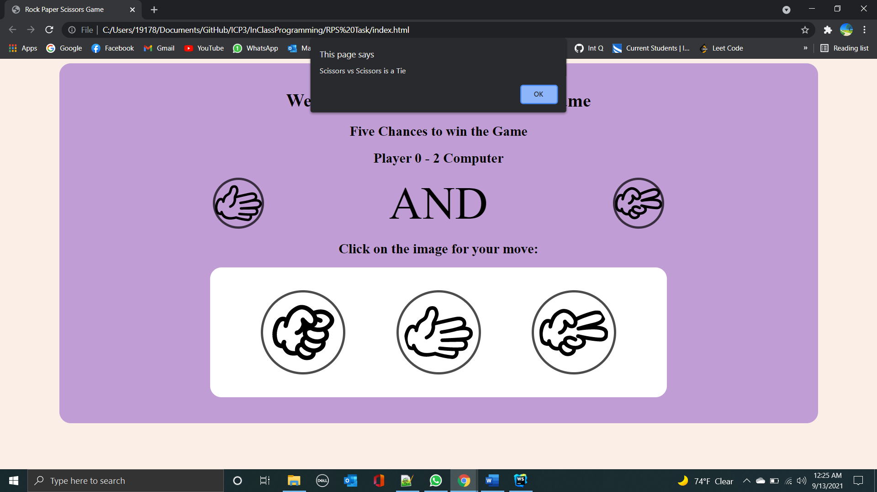

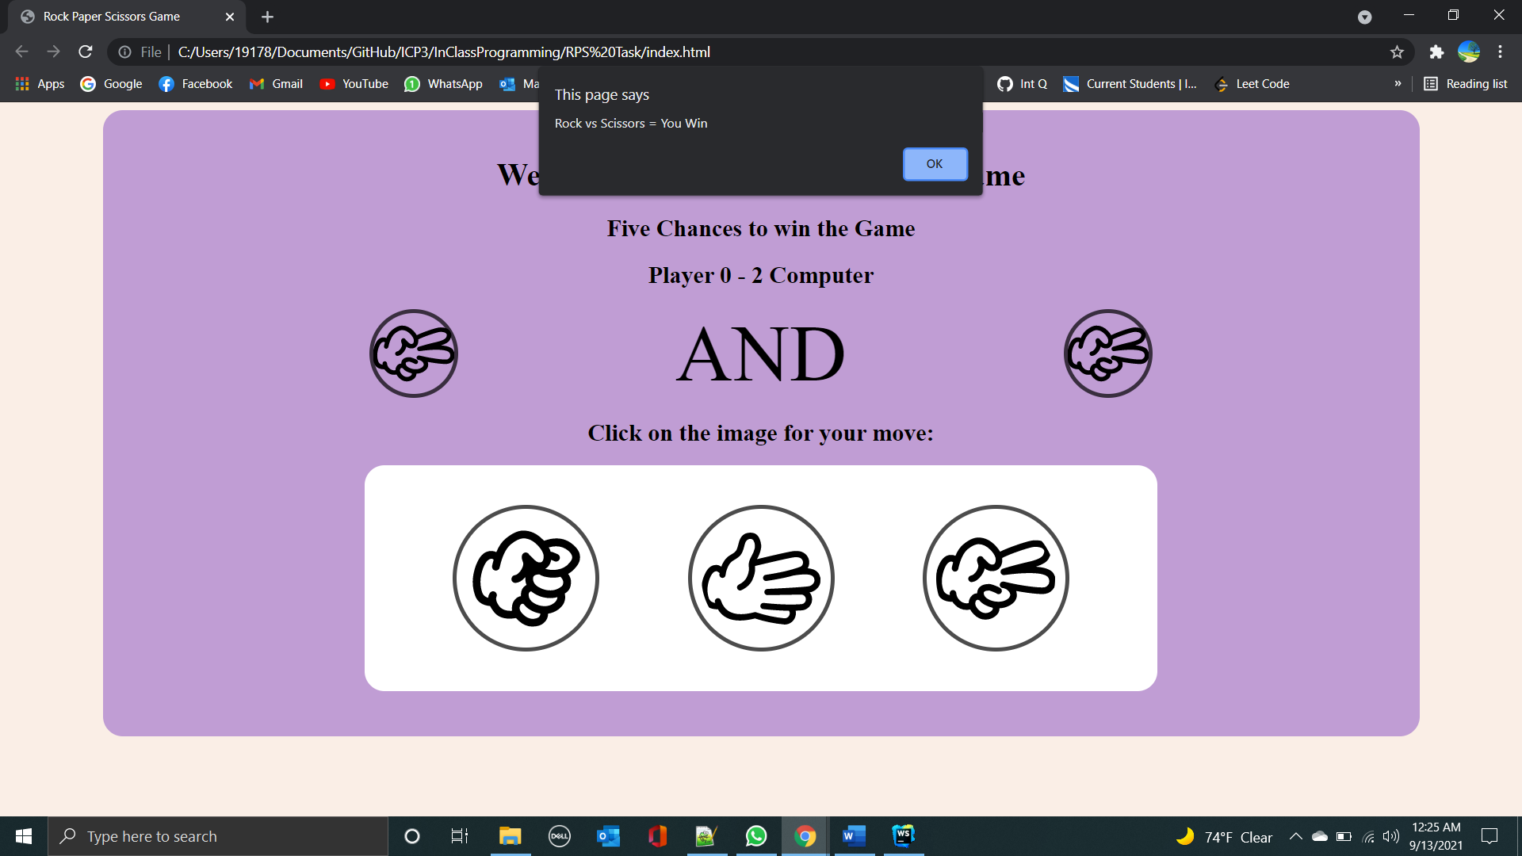

* Below, I provided some of the code snippets for the rock paper scissors game:

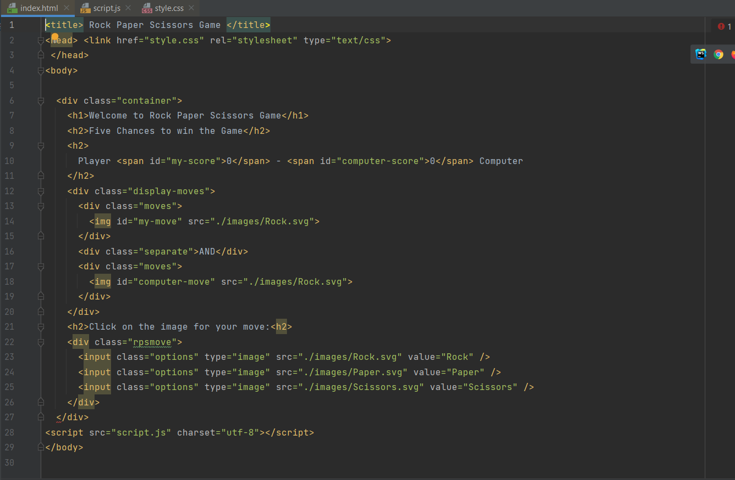

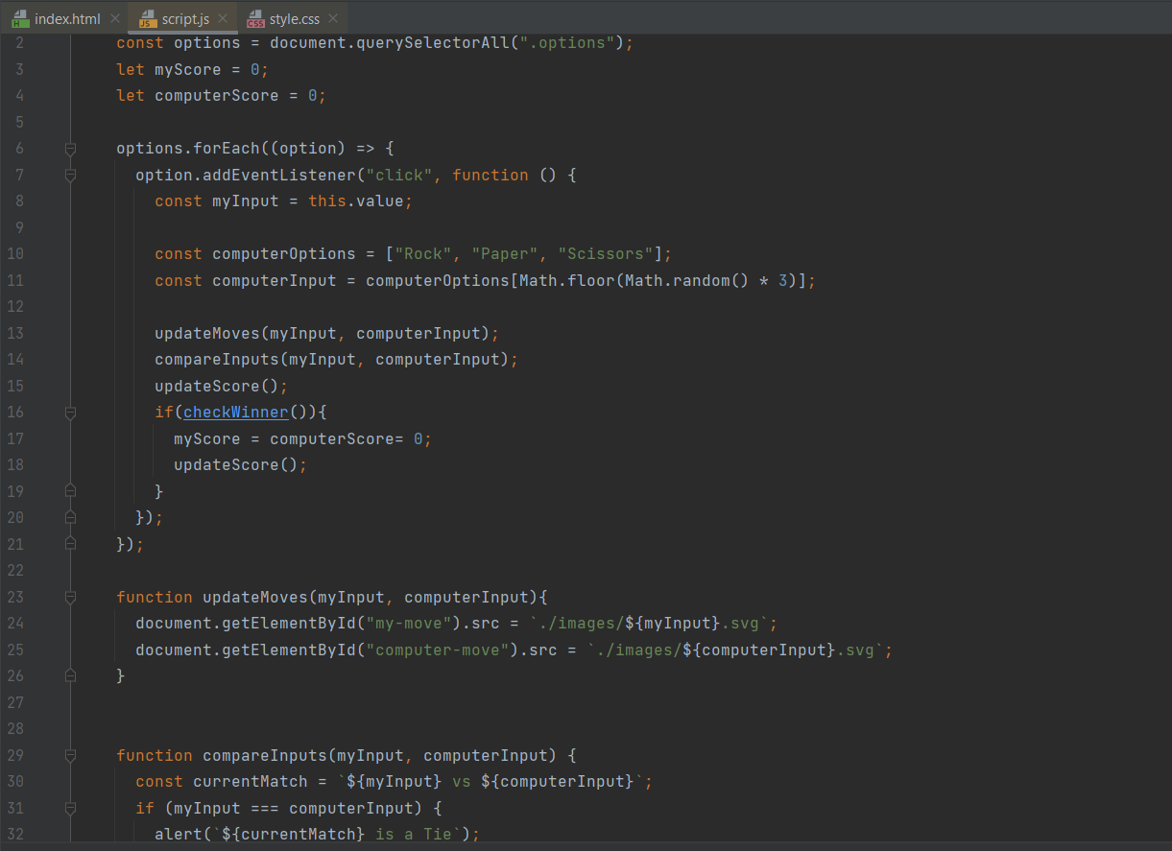

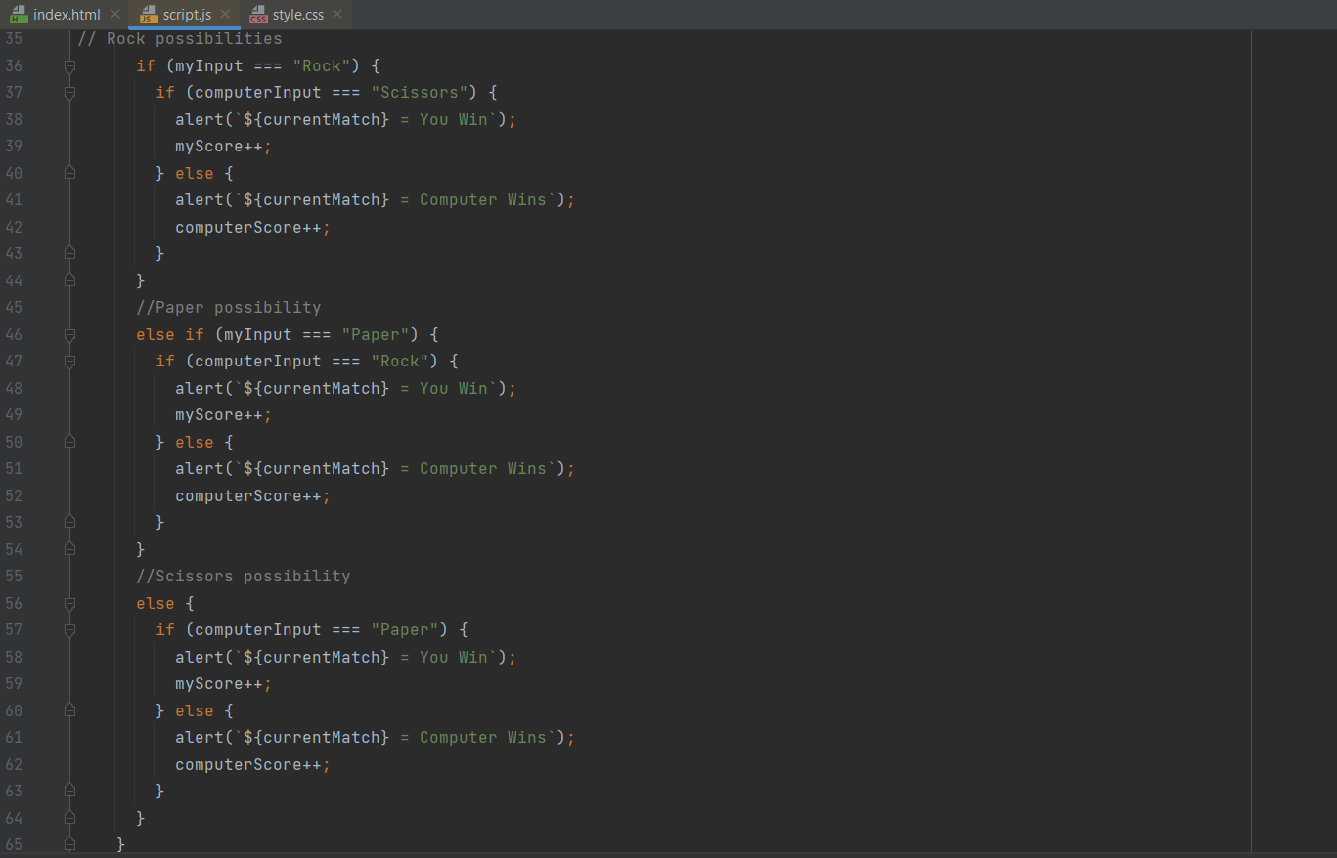

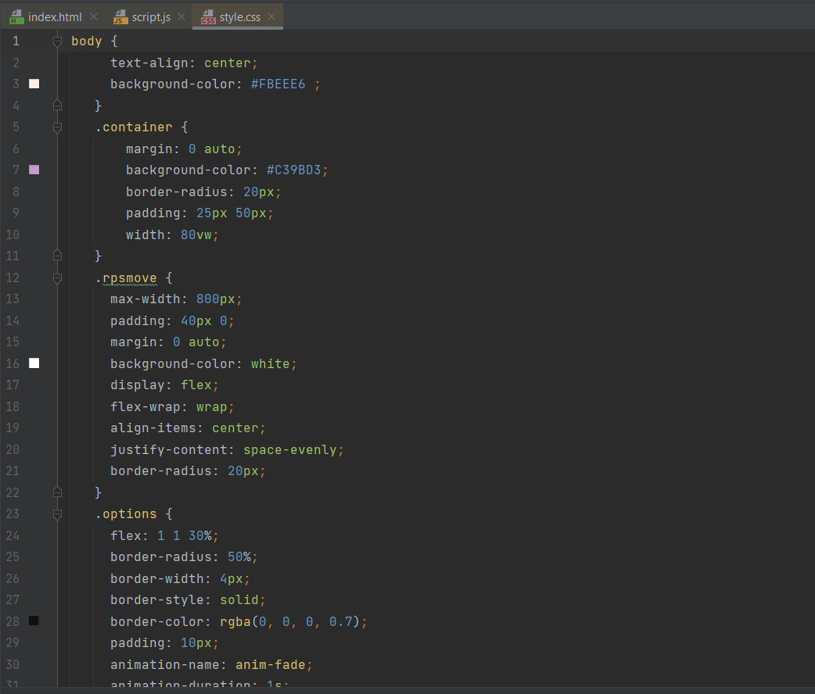

**RWD Task:**

* I implemented Bootstrap to design a responsive webpage, and here is how the interface appears.

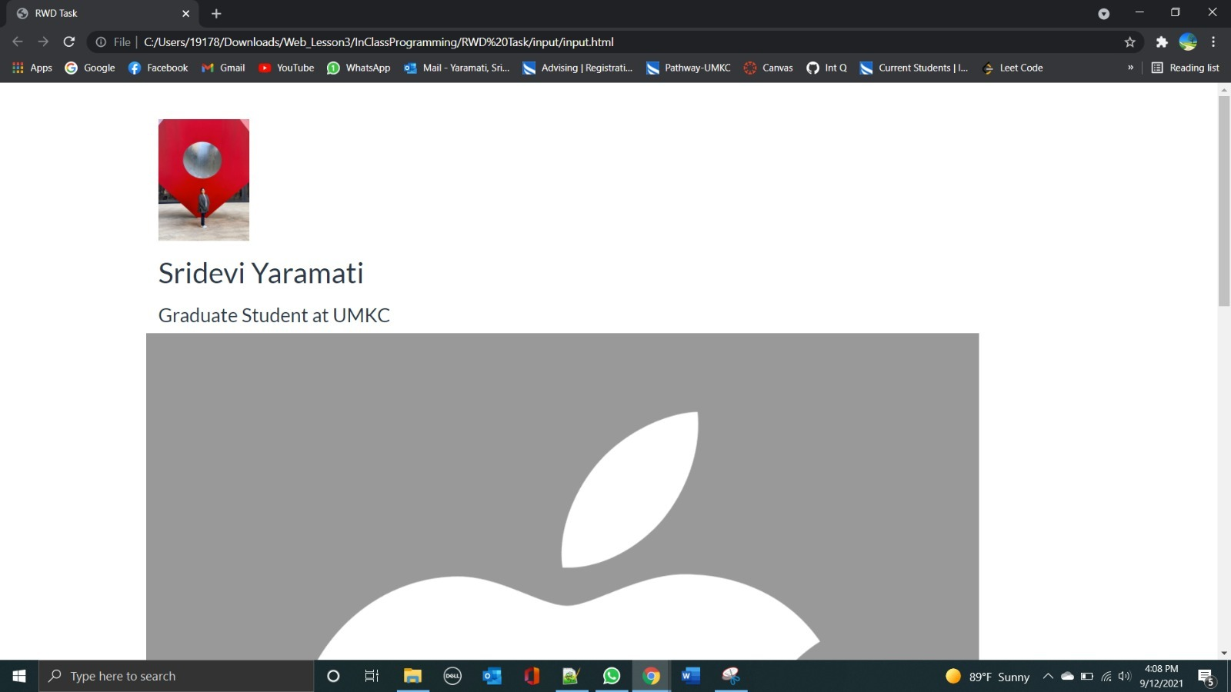

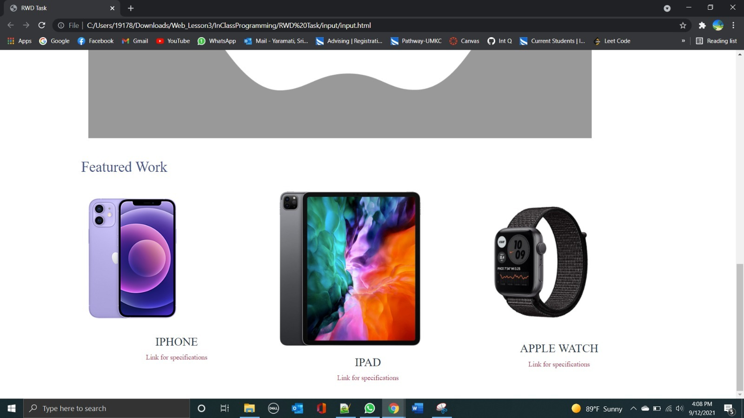

* When I enlarge or reduce the screen size, the page responds, and there is a vertical bar on the right side to scroll down to see the entire contents of the web page as shown below.

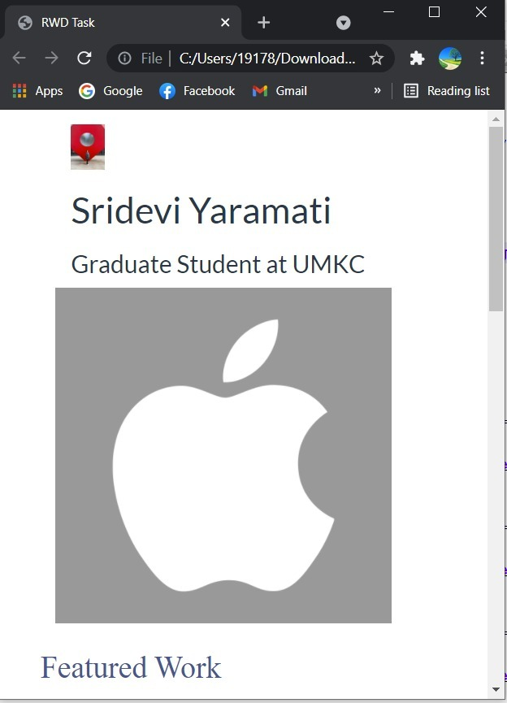

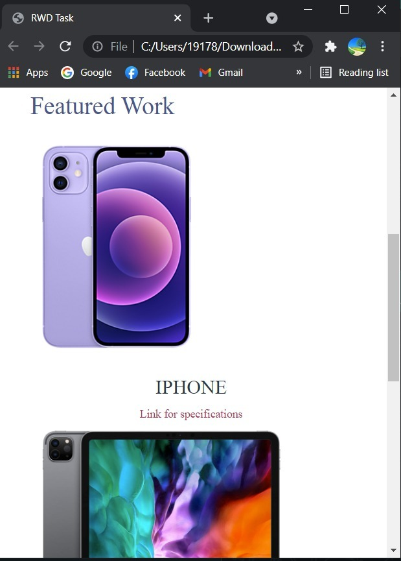

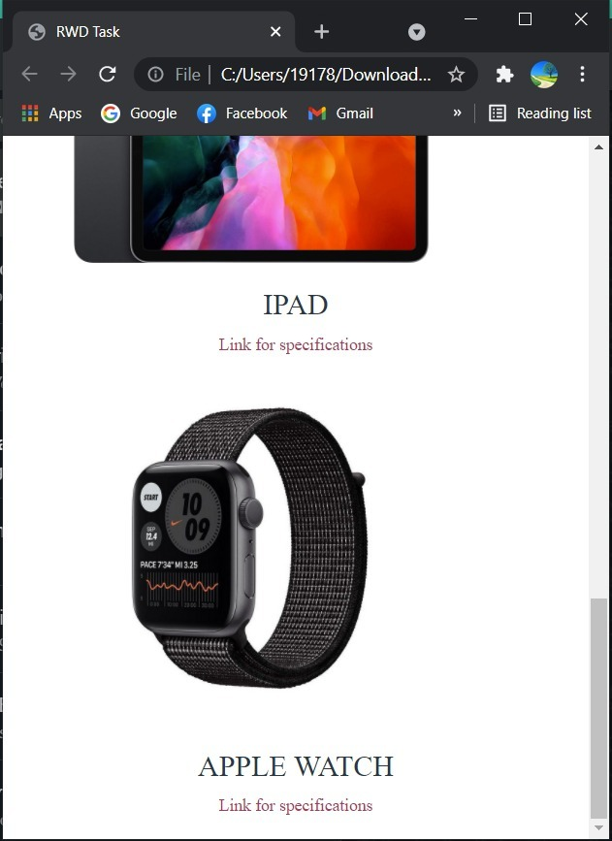

* I replaced placeholder images with new images and changed my name and designation on the webpage.
* I chose the theme of the webpage to be apple products and I provided links about apple products such as iPhone, iPad, and apple watch.
* Some of the code snippets are as follows:

